DIS-Afr-Egy-Shabtis-complete
RDER DATE  Jan 29, 2016 | ORDER TOTAL  US $192.00  + US $85.00  shipping  Order Ancient Egyptian yellow Ushabti ,Ancient Egyptian blue Ushabti ,Ancient Egyptian Blue Ushabti antiques,Ancient Egyptian blue Ushabti ,Ancient Egyptian 7 Amulets ,Ancient Egyptian 7 Amulets View order details - ORDER DATE Jan 29, 2016Contact seller - ORDER DATE Jan 29, 2016  More actions - ORDER DATE Jan 29, 2016
6 items sold by amafamily12
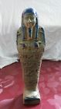  Ancient Egyptian yellow Ushabti  ( 161959979042 )  Estimated delivery Mon, Feb 22 - Mon, Feb 29  Add note | ITEM PRICE:  US $37.00 | Item Ancient Egyptian yellow Ushabti Orders 161959979042-0-0Leave feedbackReturn this item  More actions

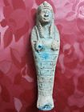  Ancient Egyptian blue Ushabti  ( 161959993919 )  Estimated delivery Mon, Feb 22 - Mon, Feb 29  Add note | ITEM PRICE:  US $40.00 | Item Ancient Egyptian blue Ushabti Orders 161959993919-0-0Leave feedbackReturn this item  More actions

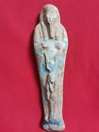  Ancient Egyptian Blue Ushabti antiques  ( 161960003661 )  Estimated delivery Mon, Feb 22 - Mon, Feb 29  Add note | ITEM PRICE:  US $35.00 | Item Ancient Egyptian Blue Ushabti antiques Orders 161960003661-0-0Leave feedbackReturn this item  More actions

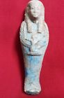  Ancient Egyptian blue Ushabti  ( 161960005542 )  Estimated delivery Mon, Feb 22 - Mon, Feb 29  Add note | ITEM PRICE:  US $20.00 | Item Ancient Egyptian blue Ushabti Orders 161960005542-0-0Leave feedbackReturn this item  More actions

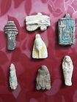  Ancient Egyptian 7 Amulets  ( 161960013668 )  Estimated delivery Mon, Feb 22 - Mon, Feb 29  Add note | ITEM PRICE:  US $30.00 | Item Ancient Egyptian 7 Amulets Orders 161960013668-0-0Leave feedbackReturn this item  More actions

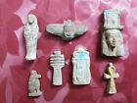  Ancient Egyptian 7 Amulets  ( 161960017622 )  Estimated delivery Mon, Feb 22 - Mon, Feb 29  Add note |  |  |  | ITEM PRICE:  US $30.00 | Item Ancient Egyptian 7 Amulets Orders 161960017622-0-0Leave feedbackReturn this item
 | ORDER DATE  Dec 22, 2015 | ORDER TOTAL  US $43.00  + US $20.00  shipping  Order Ancient Egyptian blue Ushabti antiques,Ancient Egyptian Blue Ushabti antiques View order details - ORDER DATE Dec 22, 2015Contact seller - ORDER DATE Dec 22, 2015  More actions - ORDER DATE Dec 22, 2015
2 items sold by amafamily12
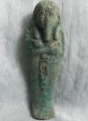  Ancient Egyptian blue Ushabti antiques  ( 161923093700 )  Estimated delivery Thu, Jan 14 - Thu, Jan 21  Add note | ITEM PRICE:  US $20.00 | Item Ancient Egyptian blue Ushabti antiques Orders 161923093700-0-0Leave feedbackReturn this item  More actions

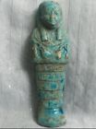  Ancient Egyptian Blue Ushabti antiques  ( 161923098286 )  Estimated delivery Thu, Jan 14 - Thu, Jan 21  Add note | ITEM PRICE:  US $23.00 | Item Ancient Egyptian Blue Ushabti antiques Orders 161923098286-0-0Leave feedbackReturn this item  More actions

ORDER DATE  Dec 22, 2015 | ORDER TOTAL  US $110.50  + US $35.00  shipping  Order Ancient Egyptian green Ushabti,Ancient Egyptian 5 Amulets antiques,Ancient Egyptian 5 Amulets antiques,Ancient Egyptian 6 Amulets antiques View order details - ORDER DATE Dec 22, 2015Contact seller - ORDER DATE Dec 22, 2015  More actions - ORDER DATE Dec 22, 2015
4 items sold by amafamily12
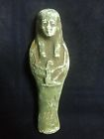  Ancient Egyptian green Ushabti  ( 161923106584 )  Estimated delivery Thu, Jan 14 - Thu, Jan 21  Add note | ITEM PRICE:  US $18.50 | Item Ancient Egyptian green Ushabti Orders 161923106584-0-0Leave feedbackReturn this item  More actions

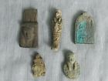  Ancient Egyptian 5 Amulets antiques  ( 161923109147 )  Estimated delivery Thu, Jan 14 - Thu, Jan 21  Add note | ITEM PRICE:  US $37.00 | Item Ancient Egyptian 5 Amulets antiques Orders 161923109147-0-0Leave feedbackReturn this item  More actions

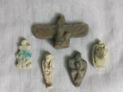  Ancient Egyptian 5 Amulets antiques  ( 161923110016 )  Estimated delivery Thu, Jan 14 - Thu, Jan 21  Add note | ITEM PRICE:  US $25.00 | Item Ancient Egyptian 5 Amulets antiques Orders 161923110016-0-0Leave feedbackReturn this item  More actions

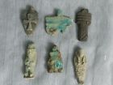  Ancient Egyptian 6 Amulets antiques  ( 161923111059 )  Estimated delivery Thu, Jan 14 - Thu, Jan 21  Add note | ITEM PRICE:  US $30.00 | Item Ancient Egyptian 6 Amulets antiques Orders 161923111059-0-0Leave feedbackReturn this item  More actions

ORDER DATE  Dec 22, 2015 | ORDER TOTAL  US $45.00  + US $20.00  shipping  Order Ancient Egyptian Ushabti antiques,Ancient Egyptian Blue Ushabti antiques View order details - ORDER DATE Dec 22, 2015Contact seller - ORDER DATE Dec 22, 2015  More actions - ORDER DATE Dec 22, 2015
2 items sold by amafamily12
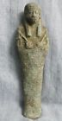  Ancient Egyptian Ushabti antiques  ( 161923073895 )  Estimated delivery Thu, Jan 14 - Thu, Jan 21  Add note | ITEM PRICE:  US $25.00 | Item Ancient Egyptian Ushabti antiques Orders 161923073895-0-0Leave feedbackReturn this item  More actions

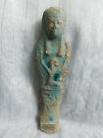  Ancient Egyptian Blue Ushabti antiques  ( 161923077618 )  Estimated delivery Thu, Jan 14 - Thu, Jan 21  Add note | ITEM PRICE:  US $20.00 | Item Ancient Egyptian Blue Ushabti antiques Orders 161923077618-0-0Leave feedbackReturn this item  More actions

ORDER DATE  Dec 22, 2015 | ORDER TOTAL  US $48.53  + US $15.00  shipping  Order Ancient Egyptian Ushabti antiques of God Bes,Ancient Egyptian Blue Ushabti antiques View order details - ORDER DATE Dec 22, 2015Contact seller - ORDER DATE Dec 22, 2015  More actions - ORDER DATE Dec 22, 2015
2 items sold by amafamily12
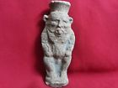  Ancient Egyptian Ushabti antiques of God Bes  ( 161922800704 )  Estimated delivery Thu, Jan 14 - Thu, Jan 21  Add note | ITEM PRICE:  US $15.00 | Item Ancient Egyptian Ushabti antiques of God Bes Orders 161922800704-0-0Leave feedbackReturn this item  More actions

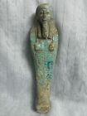  Ancient Egyptian Blue Ushabti antiques  ( 161923066755 )  Estimated delivery Thu, Jan 14 - Thu, Jan 21  Add note | ITEM PRICE:  US $33.53 | Item Ancient Egyptian Blue Ushabti antiques Orders 161923066755-0-0Leave feedbackReturn this item  More actions

ORDER DATE  Dec 21, 2015 | ORDER TOTAL  US $61.00  + US $25.00  shipping  Order Ancient Egyptian Blue Ushabti antiques of God Anubis,Ancient Egyptian Yellow Ushabti antiques View order details - ORDER DATE Dec 21, 2015Contact seller - ORDER DATE Dec 21, 2015  More actions - ORDER DATE Dec 21, 2015
2 items sold by slisli4
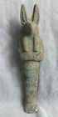  Ancient Egyptian Blue Ushabti antiques of God Anubis  ( 221972542593 )  Estimated delivery Thu, Jan 14 - Thu, Jan 21  Add note | ITEM PRICE:  US $41.00 | Item Ancient Egyptian Blue Ushabti antiques of God Anubis Orders 221972542593-0-0Leave feedbackReturn this item  More actions

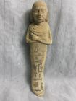  Ancient Egyptian Yellow Ushabti antiques  ( 221972558965 )  Estimated delivery Thu, Jan 14 - Thu, Jan 21  Add note | ITEM PRICE:  US $20.00 | Item Ancient Egyptian Yellow Ushabti antiques Orders 221972558965-0-0Leave feedbackReturn this item  More actions
DIS-Afr-Egy-Ushabti-Flinders Petri
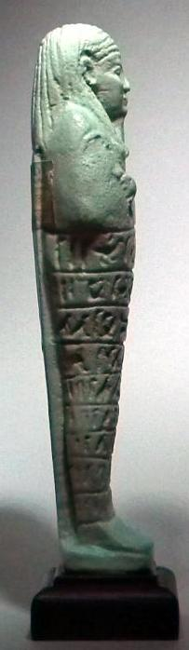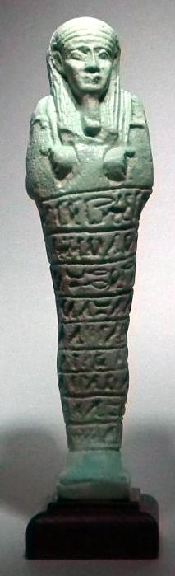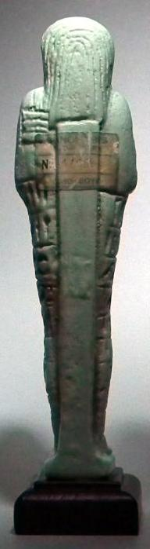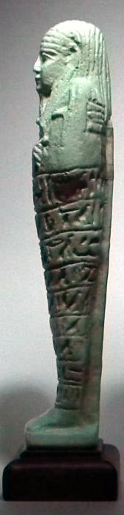
This very finely molded Ushabti Figure is typical of the style placed in ancient Egyptian burials during the 26th dynasty. The artifact has a superb pale blue-green color, a long striated wig, a plaited beard and is inscribed with the Saite version of chapter six of the Book of the Dead in nine horizontal registers of hieroglyphs. It was believed that the recitation of this text would bring such figures to life to carry out the agricultural duties demanded of its dead master in the afterlife. In readiness, the piece carries a pick, an adze and behind its left shoulder, a seed basket. A brilliant opportunity to own a valuable counterfeit by the retired and highly acclaimed British art forger John Andrews. Auctioned at a fraction of the cost of the real thing!
DIMENSIONS:
Height: 6.5 inches (165 mm). Height with Plinth: 7.2 inches (183 mm). An intact and very rare museum quality example complete with attached labeling and invoice addressed to Flinders Petrie at the Semiramis Hotel, Cairo 1926.
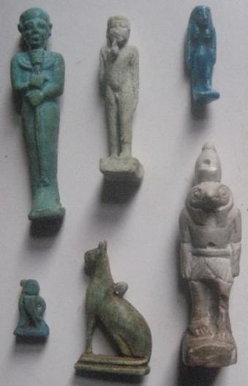

Order details

Payment details


Shipping details
Ralph J Coffman Jr
149 Atlantic Ave
Swampscott MA 01907-2427
United States

Order details
Item title | Available actions | Shipping & handling (estimated delivery*) | Price
Printer version
Seller: | Member id russelliott ( Feedback Score Of 4486) | Contact seller

Your Dec-23-12 payment is being processed through PayPal

 | Item Title:Authentic Ancient Egyptian Baby Horus & Shabti Figurines- opens in a new window or tab  Item Id:390515814566 - Price: GBP 207.55  Quantity:1  Having a problem with this purchase? We can help |  | Standard Int'l Postage : GBP 9.99  Estimated delivery: Varies*  You can contact the seller for more information. | GBP 207.55
  View PayPal transaction- opens in a new window or tab
Subtotal: | GBP 207.55
Shipping & handling: | GBP 9.99
Total: | GBP 217.54

Order details

Sales order
Sold by shoukhann ( 476 )

Delivery package 1 of 1
Estimated delivery Monday, Feb 8, 2016
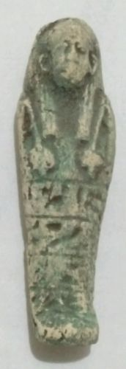

Ancient Egyptian USHABTI Amulet 300 BC RARE
Item price | $22.50
Quantity | 1
Item number | 222005219953
Shipping service | Economy Shipping

No estimate available
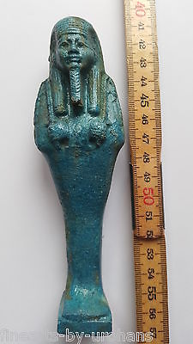

BEAUTIFUL EGYPTIAN FAIENCE STYLE USHABTI / SHABTI. EXTREMELY NICE.
Item price | GBP 35.00
Quantity | 1
Item number | 331745442971
Shipping service | Standard Int'l Postage
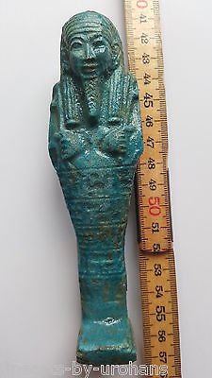

BEAUTIFUL EGYPTIAN FAIENCE STYLE USHABTI / SHABTI. EXTREMELY NICE.
Item price | GBP 35.00
Quantity | 1
Item number | 331745445051
Shipping service | Standard Int'l Postage

